Incident Investigation Principles

All rights for the pictures contained in this bulletin are protected.

When we decide to investigate an incident, practice shows that effective learning is often still not done because we are unable to learn the correct lesson from the investigation. This is because many incident investigations do not ask the right questions. There is largely agreement in the academic literature about the correct approach to incident investigation, but in practice it appears that incident investigation is not always carried out in this way.
The way in which the occurrence of an accident is viewed largely determines the outcomes. A different focus will logically lead to a different outcome. The literature describes a development of incident viewing that runs from the root cause approach, to the epidemiological approach to the systemic approach. However, this does not mean that it is also the most commonly used approach in incident investigation practice.

Root cause approach
The root cause approach assumes that a negative event (the root cause) triggers a series of consecutive events that ultimately lead to the incident. The causal cause and effect relationship of these events is linear and deterministic. This means that when the root cause can be identified and removed, the potential for the incident is also removed. The root cause approach is a widely used method that has proven its worth. Such an approach works well in relatively simple systems where the cause of incidents must mainly be sought in technical failure or human action.
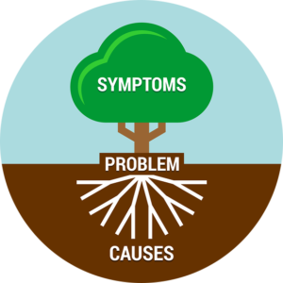

Epidemiological approach
According to the epidemiological approach, an incident is explained as an interplay between latent and active failure. The comparison is made with the development of a disease, hence the name. Latent factors include such things as inadequate management practices or a poor safety culture. These factors can be present in an organization for a very long time without directly leading to accidents. However, they can have a negative impact on the conditions under which people work in the workplace. This increases the chance of wrongdoing (active failure). When latent failure and active failure "come together" an incident occurs.
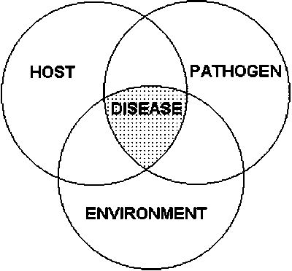

Systemic approach
The systemic approach sees incidents as the result of an uncontrolled interaction between the different parts of a system. Accidents are caused because technology, people and the environment interact in a way that is rational at the local level, but creates unsafe conditions in the system without realizing it. These unsafe conditions are then not corrected. From this perspective, the mere removal of a root cause is not sufficient to prevent incidents in the future, because the complexity means that there is no single root cause. This systemic approach leads to a better and deeper understanding of the origin of incidents, but has the disadvantage that it costs more resources and requires more expertise and (theoretical) knowledge to be able to apply.
